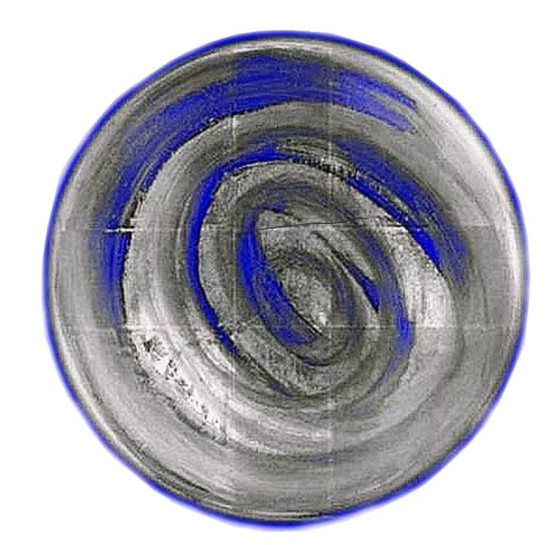
Big Blue Asset Management
Asset Management: Investments: Trusts: Tax Haven
Asset Management Co-Operation of Universal Law Community Trust
“For The People”
trust@universallawcommunitytrust.com
www.universallawcommunitytrust.com
© All Rights Reserved
RESTORATION: RIGHTS: CREDITORS
(U.C.C. 9-609 / 610)

THIS NOTICE IS TO NOTIFY ALL PREVIOUSLY INTERESTED PARTIES OF A PEACEFULE SURRENDER OF “COLLATERAL” ONCE KNOWN BY LONGITUTDE AND LATITUDE REFERENCE:
53.5500N LATITUDE AND 2.4333 W LONGITUDE
ONCE CLAIMED AND TITLED (U.K / H.M GOVERNMENT) FILED AS COLLATERAL INSIDE (SECURITIES EXCHANGE COMMISSION, WASHINGTON D.C) UNDER THE SECURITEIS AND EXCHANGE ACT
ACCESSION NUMBER: 9999999997-08-048874
FILING DATE 2008-19-12
CIK CODE: 0001452617
MAKING (H.M.GOVERNMENT) (FOREIGN GOVERNMENT) SUBJECT:
UNIFORM COMMERCIAL CODE
See: https://www.sec.gov/Archives/edgar/data/1452617/999999999708048874/9999999997-08-048874-index.htm
For proof of this claim.

In resonance but not in accordance with (UCC 9-609 9-610), a “Debt Equity Swap” has been completed through the legally matured consent of the Secured Party Creditors, who have assigned their shares and credit unto Universal Law Community Trust by way of irrevocable deed.

Due to the outstanding debt owed by (HER MAJESTY’S GOVERNMENT) in excess of 10 Quadrillion slave tokens ( dollars, pounds, euros et al) recorded and filed :
UCC 1 FINANCING STATEMENT: FILING NUMBER-2020-056-5342-1 25/02/2020
Remaining unsettled a RESTORATION: RIGHTS: CREDITORS
( a Restoration of Rights of the Creditors) has been undertaken.
All assets, shares, minerals, commodities, utility transmitting accounts, broker accounts, property and trading accounts and treasury accounts and trusts have been surrendered by the creditors who were once implied by this corporation as debtors, (the people of England, Ireland, Scotland and Wales and what was once referred to as the British Empire ) presumed to be employees of HER MAJESTYS GOVERNMENT (HMT/ HMG) to offset the debt that unsolicited commercial intercourse and undisclosed terms and conditions of the use of the legal fiction caused.
In doing so the people of Universal Law Community Trust discharged the debt on behalf of HER MAJESTY’S GOVERNMENT and the private corporation has only empty credit files, no credit rating and is therefore unable to trade and is made obsolete never to be resurrected. All credit and collateral has been assigned under strict Non Disclosure Terms known as NDA1*** and all agents once acting in their roles within the private corporation are given notice of 28 days from the date of this notice that they are required to assign their consent unto Universal Law Community Trust, adopt the EMOVEN seal as authentication of documentation in order to remain in their positions, currently held.
A New World Order as defined and in symphony with Universal Law has been issued which those remaining in (office) will be granted right of use of to implement peacefully and without reservation.
Those agents of HER MAJESTY’S GOVERNMENT who do not wish to facilitate the New World Order as defined under Universal Law will be given a Kindness Credit Account to settle their liabilities and to discharge their debts and charges and retire from their roles no later than 28 days.
The New World Order includes a reset of the planet’s economy and the exchange of slavery for another currency. Kindness Credits.
As our currencies token is rocks and the debt remained outstanding our debt equity swap constitutes one rock, once known as Earth.
This debt therefore is now considered settled and the restoration process has commenced.
This notice is politely served to all parties to give due, disclosure to enable consideration, acceptance, a meeting of the minds and consent or to decline the offer of re settlement in their roles currently held.
This notice does not form or imply and contract and is simply for information and legal purposes only.
By Order:
Ministry: Remedy
Universal Law Community Trust.
A community of secured party creditors who Trust in Universal Law.

All Rights Reserved.
©
E:4:Y3076:C33:M0
(18 May 2020 )

