  Beneficiary Name: | Emoven
  Beneficiary Address | YOUR ADDRESS HERE
  Beneficiary Email: | Fran. Sciberras@prontonmail.com
  Delivery Address: | DELIVERY ADDRESS
  Exchange Account: | YOUR KC ACCOUNT
  Wirth | KC Account of the service
   | Your require
CLAIM FORM
 | Amounts | Not sure what is meant for here? | Account Numbers | ?

Kindness Credits
Conversion
Electricity = 40 a onth

Gas = £40 a month
Water = £20.22 a month
Council Tax = £109 a month

Debt = Total =
Santander Mastercard ACCOUNT NUMBER HERE
Amount trying to extort: £1,853.35

Santander 78830944, 09-03-58
Amount trying to extort: loan= £3,481.93

Name of corporation: Santander UK plc.
Contact details: 2 Triton Square, Regent's Place, London, NW1 3AN
Registered Number 2294747

Credit Charges = £40 a month

Organic Food = medium / Veg box a month
Organic Food = Small / Fruit box a month
Olive Oil = x 1 small bottle a month
Chocolate = 3 bars of dark 70/80%, a month

Exchange Swap
(what are you offering in exchange)
Cleaning, organisation of House, office, wardrobe = in the Brighton area hub.

No Mortgage / I have rent = £450 a month
Minister EMOVEN Robes = small/medium size 10-12/UK size
Oracle Services ( Teaching) = I would love to receive this please. Thank you

Electricity Meters = £50 a month
Gas Meters = £40 a month

Travel Costs = £40

Minister Your Mind Ebook. Y

Total KC

Total in slave tokens : £16.00 for ebook 2 KC

IBAN : GB42LOYD30944311256368 or 30-94-43 11256368 (RG SWAIN) this is our clearance account.

Please add Kindness Credit Account number and your own unique 4 digit code that you choose

Energy Exchange : How to use this form :
You add in the box above what you are requiring on a monthly / Yearly basis
Such as rent / clothing/ travel. This then goes as a claim against your account to create and release that amount of Kindness Credits converted into prepaid credit for those who you are doing exchanges with.
Converting someone else to Kindness Credits.
You simply create the party you wish to exchange with a proton email account and get them to send a request for a Kindness Credit Account to it with your KC account number on. This is pay it forward.

Then you :
You fill out the Kindness Credit Note as follows
1) the date
2) The amount in Kindness Credits
3) The thumbprint
4) The signature

You write, like you would on a cheque, Pay (KC account you want to credit ) From ( Your KC account ) In Kindness Credits

Issuing Kindness Credits into your community: How to:

You write the IBAN number on the back of the note and give that to someone instead of cash. They then send this to our KC clearance address with their IBAN number to have the credit sent to them or they use it to exchange with products from the site this is how we put the KC into the community. Very Simple
The address to send the notes to are : 125 The Suites Holme Street Halifax HX7 8AA

Please fill out the form below so that you can account for the exchange through the FIAT system

1) 2) 3)
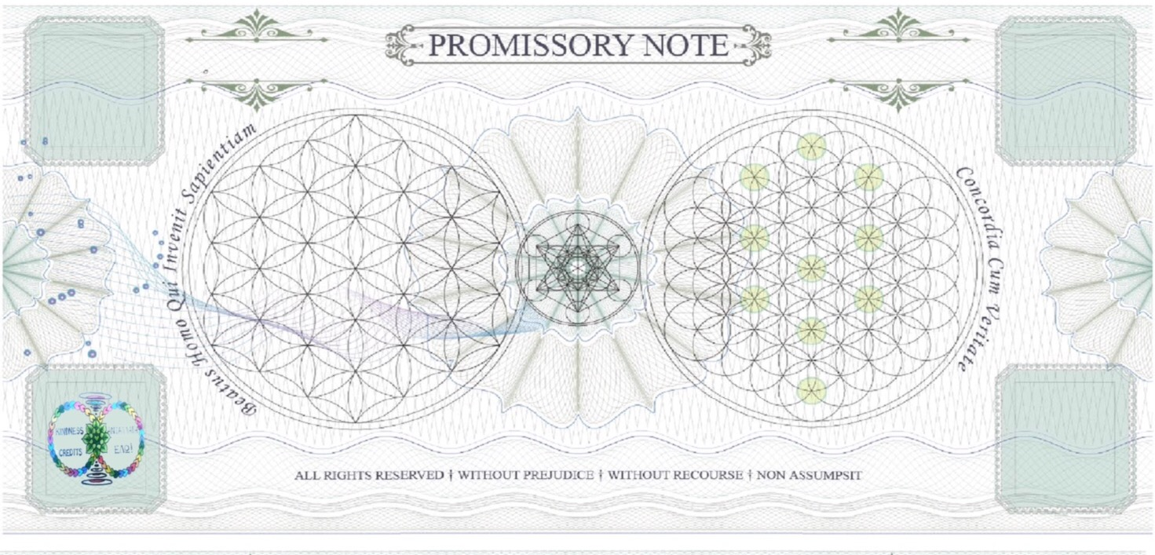
4)

